Create an ARIMA model for time series forecasting.
EX:No.8
DATE:19/04/25

AIM:
Write a program to Create an ARIMA model for time series forecasting

ALGORITHM:
Step 1: Install required libraries (if not already installed).
Step 2: Import necessary libraries (pandas, numpy, matplotlib).
Step 3: Load air pollution data, parse dates, and set 'date' as the index.
Step 4: Remove duplicate timestamps and fill missing values.
Step 5: Select the 'pollution_today' column.
Step 6: Remove outliers using the IQR method.
Step 7: Ensure daily data frequency.
Step 8: Resample to weekly average (optional, not used in the plot).
Step 9: Create a figure and plot daily pollution levels as a line graph.
Step 10: Set labels, title, and legend for the plot.
Step 11: Show the plot.

CODE:

import pandas as pd
import matplotlib.pyplot as plt
from statsmodels.tsa.stattools import adfuller
from statsmodels.graphics.tsaplots import plot_acf, plot_pacf
from statsmodels.tsa.arima.model import ARIMA
# 1. Load the data

file_path = r"C:\Users\HARISH\Desktop\notes\time series and analysis pratical\ex 6\accident_time_series_1000_rows.csv"

df = pd.read_csv(file_path)
df['Date'] = pd.to_datetime(df['Date'])
df.set_index('Date', inplace=True)

# 2. Plot the time series
plt.figure(figsize=(12, 6))
plt.plot(df['Total Accidents'], label='Total Accidents')
plt.title('Total Accidents Over Time')
plt.xlabel('Date')
plt.ylabel('Total Accidents')
plt.legend()
plt.grid(True)
plt.show()

# 3. ADF Test for stationarity
result = adfuller(df['Total Accidents'])
print("ADF Statistic:", result[0])
print("p-value:", result[1])
print("Critical Values:", result[4])

# 4. ACF and PACF Plots
fig, axes = plt.subplots(1, 2, figsize=(14, 5))
plot_acf(df['Total Accidents'], ax=axes[0], lags=40)
plot_pacf(df['Total Accidents'], ax=axes[1], lags=40, method='ywm')
plt.show()

# 5. Fit ARIMA Model (Adjust order based on ACF/PACF)
model = ARIMA(df['Total Accidents'], order=(2, 0, 2))
model_fit = model.fit()
print(model_fit.summary())

# 6. Forecast future values
forecast = model_fit.forecast(steps=30)
plt.figure(figsize=(12, 6))
plt.plot(df['Total Accidents'], label='Historical')
plt.plot(forecast, label='Forecast', color='red')
plt.title('30-Day Forecast of Total Accidents')
plt.xlabel('Date')
plt.ylabel('Total Accidents')
plt.legend()
plt.grid(True)
plt.show()

OUTPUT:

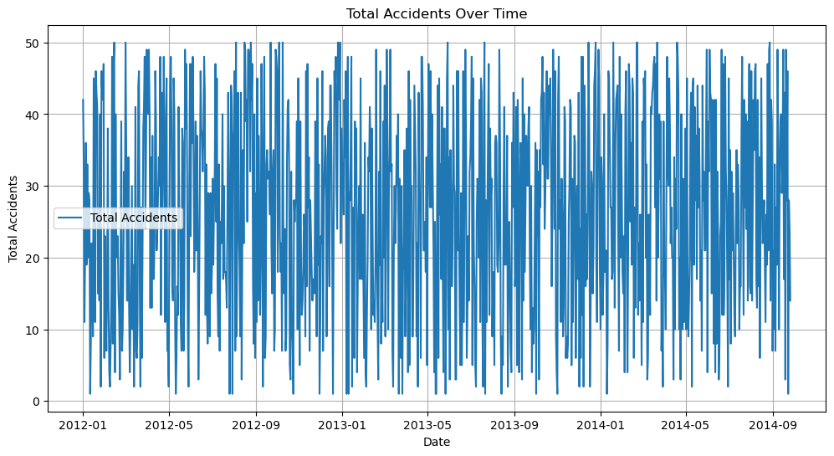

SARIMAX Results
==============================================================================
Dep. Variable: Total Accidents No. Observations: 1000
Model: ARIMA(2, 0, 2) Log Likelihood -4080.435
Date: Sat, 19 Apr 2025 AIC 8172.871
Time: 13:40:53 BIC 8202.317
Sample: 01-01-2012 HQIC 8184.063
- 09-26-2014
Covariance Type: opg
==============================================================================
coef std err z P>|z| [0.025 0.975]
------------------------------------------------------------------------------
const 26.2640 0.469 56.007 0.000 25.345 27.183
ar.L1 -1.2976 0.343 -3.787 0.000 -1.969 -0.626
ar.L2 -0.5172 0.334 -1.548 0.122 -1.172 0.138
ma.L1 1.3332 0.330 4.044 0.000 0.687 1.979
ma.L2 0.5715 0.320 1.789 0.074 -0.055 1.198
sigma2 204.9937 14.334 14.301 0.000 176.900 233.088
===================================================================================
Ljung-Box (L1) (Q): 0.00 Jarque-Bera (JB): 57.68
Prob(Q): 0.98 Prob(JB): 0.00
Heteroskedasticity (H): 0.98 Skew: -0.05
Prob(H) (two-sided): 0.88 Kurtosis: 1.83
===================================================================================

RESULT:
Thus, the program using the time series data implementation has been done successfully.

